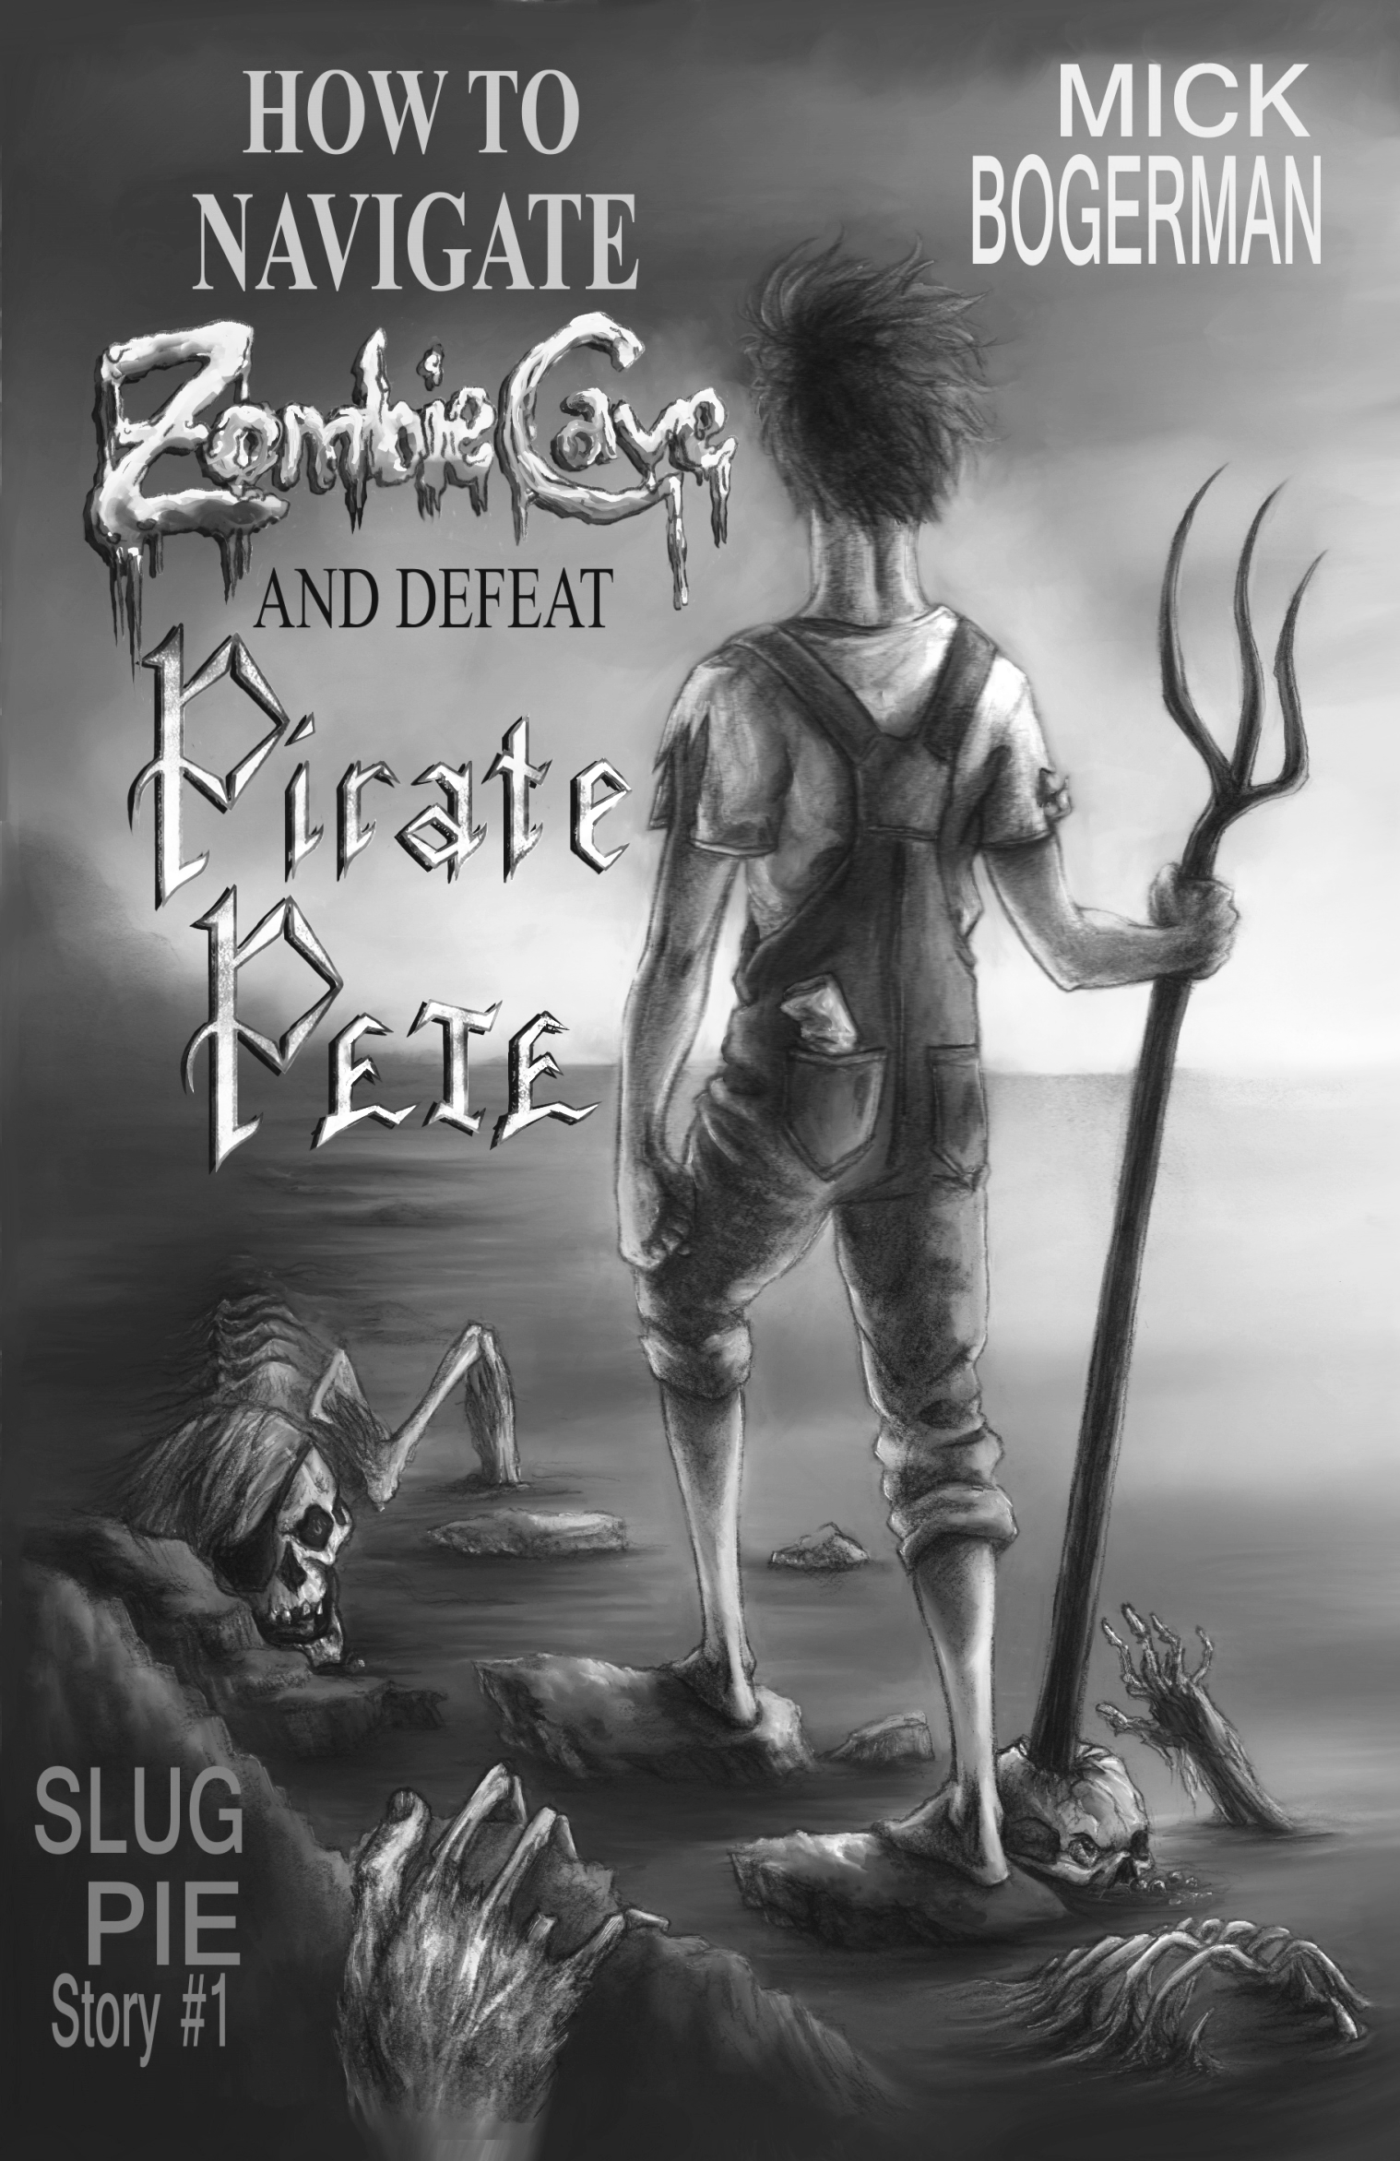

Author, Mickey "Mick" Bogerman has lived in Beachwood, North Carolina all his life. Mostly he tries to stay out of trouble, but mostly trouble seems to find him anyway. He has a knack for antagonizing scary creatures and girls, not necessarily in that order.
Mick's favorite subjects in school are science (slime, rockets, bugs, and rocks-- what's not to like?), gym class (running, climbing, throwing-- more stuff to like), and reading (yay Mr. Corcoran lets him read whatever he likes-- like comic books).
Speaking of comic books, Mick's favorites are X-Men, Demon Knights, Spiderman and Batman.

About Mick Bogerman
Slug Pie Stories take place in the fictional town of Beachwood, North Carolina where 12-year-old Mick Bogerman and his younger brother Finley protect their family and friends from the not-so-friendly creatures lurking in the shadows.
Join the Bogerman brothers on their exciting adventures and learn how to defeat pirate zombies, bloodthirsty mermaids, killer robots, and whatever else threatens Beachwood and the people they care about.
Discussion Guide
Fall 2014
Slug Pie Stories, LLC

The Slug Pie Story World
ISBN 978-0-9903801-0-8, Paperback, Copyright 2014, 114 pages, $6.99 Dimensions: 7.8 x 5.1 x 0.2 inches

ISBN 978-0-9903801-1-5, EPUB,
Copyright 2014, $2.99

ISBN 978-0-9903801-2-2, Kindle,
Copyright 2014, 67 pages estimated, $2.99

Book Specifications
Slug Pie Stories, LLC
Frankfort, IL USA
About Slug Pie Story #1
Armed with a pitchfork, miner’s hat, and map, Mick Bogerman dares to hunt for pirate treasure in Zombie Cave. His little brother Finley is tied up at the beach. Literally--Mick tied him up. No one needs a little brother tagging along when you’re going to slay the undead.
But Mick soon wishes he’d taken some human company with him, because lurking in every corner, reaching from every crevice, is another hungry corpse. No wonder the place is named Zombie Cave! And finding treasure in the twisty tunnels is a lot harder when your map disintegrates. And man-oh-man the cold, dark tide chases fast. But the worst part about fighting off ravenous flesh-eaters is the one monster deadlier than a regular zombie . . . the worst of the worst . . . Pirate Pete.
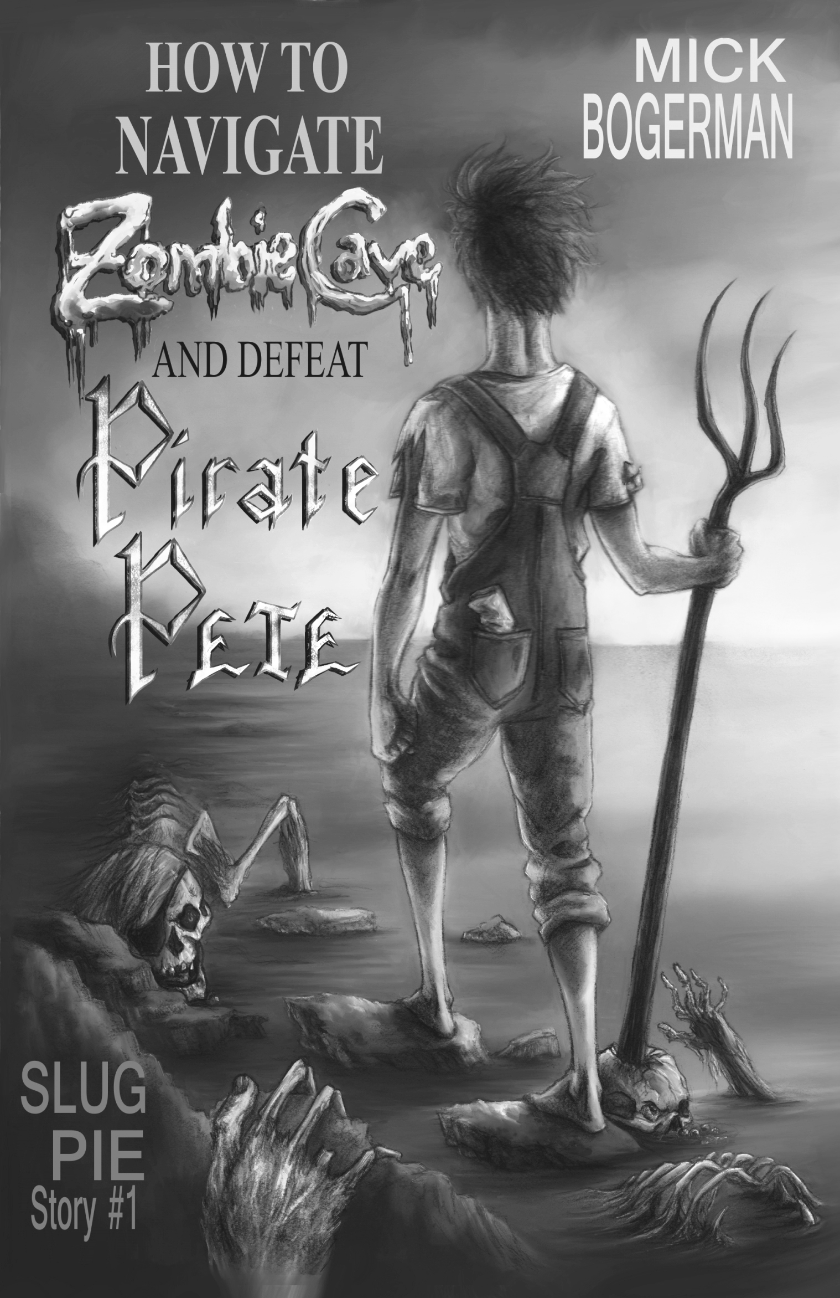
1. In the first line of the first chapter, Mick ties his little brother to a stake. Why would he do such a thing to someone he cares about? Do you think he did the right thing? Why or why not? (CCSS.ELA-Literacy.RL.3.6)
2. What is Mick’s plan for getting to the treasure? What problems do you see with this plan?
3. Mr. Protchensgi (Mr. Gee) owns a comic book store in Mick’s town and is the person who originally told Mick about Pirate Pete. Mr. Gee uses the following words to describe Pirate Pete: “selfish,” “rogue,” and “swindler.” What is your opinion of Pirate Pete? (CCSS.ELA-Literacy.RL.5.4)
4 After Mick stops the first zombie he meets, he wants to leave the cave and go back home. What makes him decide to stay? Would you have stayed? Why or why not? (CCSS.ELA
Literacy.RL.5.2)
Discussion Questions
General
1. At the beginning of the book, Mick addresses the parents of his readers with a Warning Note. What do you think is the purpose of this note? Do you think the note makes the book more or less appealing to kids? Why or why not?
2. Why does Mick organize his book into Steps instead of Chapters? (CCSS.ELA-Literacy.RL.5.5)
3. Do the titles of each of the steps provide some clues as to what will occur? Would you have named any of the steps differently? If so, what would you name them? (CCSS.ELA-Literacy.RL.5.5)
4. At the end of the book, Mick and Finley provide a list of materials to bring next time. Is there anything you would bring that is not on the list? Why?
5. Describe the cover of the book. Does the cover of the book enhance the story? How? (CCSS.ELA-Literacy.RL.3.7)
Common Core State Standards assigned to the discussion questions in this guide are noted for grades 3-6. For more information on the Common Core, visit statestandards.org
Discussion Questions
STEPS 1-3
Discussion Questions
STEPS 4-6
1. During Step 4, Mick imagines himself becoming famous for capturing a zombie. Why does he decide that isn’t such a good idea? Do you agree? Why or why not? (CCSS.ELA-Literacy.RL.5.1)
2. How does Mick react after he reads the message left inside Harold’s pocket? (CCSS.ELA-Literacy.RL.3.1)
3. At first Mick feels fear toward the bats. Why does Mick change his mind about them?
4. What is Mick’s impression of Pirate Pete?
5. After Mick meets the parrot, why does he go back to see Harold? What does he hope to eventually get from the parrot? What surprises him about the bird? (CCSS.ELA-Literacy.RL.4.3)
Mick Bogerman
Finley Bogerman
Harold Cooper
Polly
Pirate Pete
Karl Wheetly

The cave
The tunnel
The pipe works room
The tide
The open sea
1. Mick tells us in Step 7 that he sometimes gets into trouble for not slowing down and thinking things through. What does he mean by this? Give some examples from the story so far. Have you ever gotten into trouble for rushing into action? (CCSS.ELA-Literacy.RL.3.3)
2. What does Mick think is the cause of the leaking asphalt? What evidence is there to suggest that Mick is right?
3. What are some of the ways that Finley helps Mick? (CCSS.ELA-Literacy.RL.4.1)
4. Describe how Mick and Finley are different. How are they the same? (CCSS.ELA-Literacy.RL.5.3)
5. At the end of step 10, a zombie pulls Finley under the water and then Mick saves Finley in Step 11. Besides risking his own life to save someone else’s, what makes Mick’s action “noble”? (CCSS.ELA-Literacy.RL.6.1)
1. How do Mick and Finley finally get out of the cave? Why would using this method be considered “ironic”?
2. In Step 12, why do Mick and Finley have to “move away from shore”? Why would this be considered “counterintuitive”?
3. Why do you think Mick doesn’t tell Karl and Sam about Zombie Cave? Would you have told them? Why or why not? (CCSS.ELA-Literacy.RL.3.6)
4. Why does Mick laugh when he finds the gold coin in his pocket?
5. Do you think Mick regrets entering Zombie Cave? Why or why not? (CCSS.ELA-Literacy.RL.4.2)

GUIDE TOPICS:
Family, Goals, Strategy, Obstacles, Disappointment, Loss, Cleverness, Main Idea and Details, Drawing Conclusions and Making Inferences, Plot, Character, Setting, Story Elements, Reading Response, Courage, Bravery, Heroism, Creativity and Imagination, Honor

Describe the characters and their personalities. Do any of them change during the story? How? (CCSS.ELA-Literacy.RL.4.3)

WWW.SlugPieStories.COM
a kid-friendly website
Help vote for the next Slug Pie Story
Send in your fan art
Share zombie killing tips and tricks
Print Mick’s favorite family recipes
Learn more about your favorite Slug Pie Story characters
And more . . .

Discussion Questions
STEPS 7-11

Describe the setting. How does it change during the story? Do the changes in setting increase the tension in the story? (CCSS.ELA-Literacy.RL. 4.1 & 4.3)
Discussion Questions
STEPS 12-13
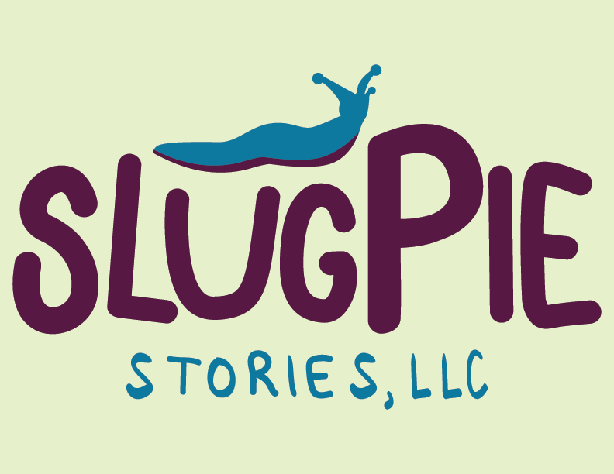
Illustrations © 2014 by Kat Powell from How to Navigate Zombie Cave and Defeat Pirate Pete. Discussion guide written by Karin Blaski, Associate Professor at Rock Valley College
Lexile Measure: coming soon
Ages: 8-12
Grades: 3rd-7th
Genre: Series, Fantasy
Categories: Children’s Fiction, Middle Grade Fiction, Pre-Teen Fiction, Spine-Tingling Horror, Action and Adventure, Monsters

About this book
Publisher’s Note: How to Navigate Zombie Cave and Defeat Pirate Pete is a work of fiction. Names, characters, places, and incidents are a product of the author’s imagination. Locales and public names are sometimes used for atmospheric purposes. Any resemblance to actual people, living or dead, or to businesses, companies, events, institutions, or locales is completely coincidental.
This document may be downloaded, printed, and photocopied for free distribution within educational settings.
Slug Pie Stories, LLC
8126 W. Evergreen Lane
Rockford, IL 60423, USA
TO:

