
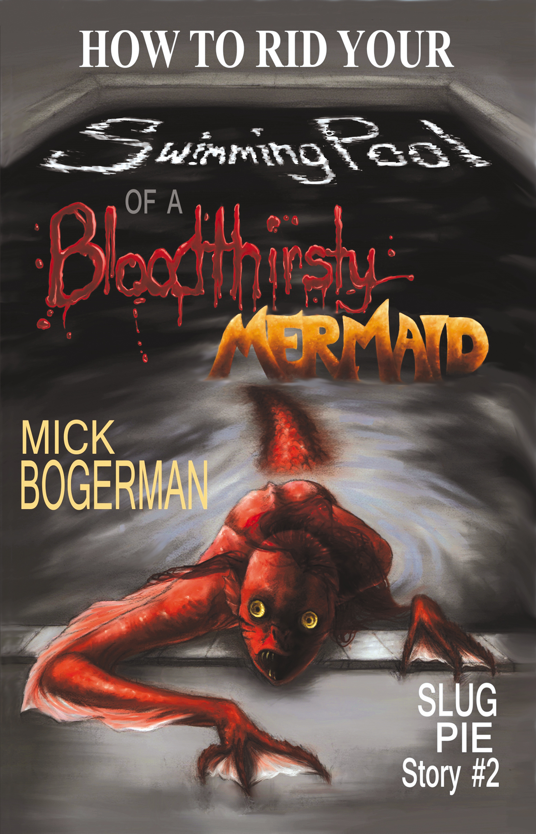
Author, Mickey "Mick" Bogerman has lived in Beachwood, North Carolina all his life. Mostly he tries to stay out of trouble, but mostly trouble seems to find him anyway. He has a knack for antagonizing scary creatures and girls, not necessarily in that order.
Mick's favorite subjects in school are science (slime, rockets, bugs, and rocks-- what's not to like?), gym class (running, climbing, throwing-- more stuff to like), and reading (yay Mr. Corcoran lets him read whatever he likes-- like comic books).
Speaking of comic books, Mick's favorites are X-Men, Demon Knights, Spiderman and Batman.

About Mick Bogerman
Slug Pie Stories take place in the fictional town of Beachwood, North Carolina where 12-year-old Mick Bogerman and his younger brother Finley protect their family and friends from the not-so-friendly creatures lurking in the shadows.
Join the Bogerman brothers on their exciting adventures and learn how to defeat pirate zombies, bloodthirsty mermaids, killer robots, and whatever else threatens Beachwood and the people they care about.
Discussion Guide
Fall 2014
Slug Pie Stories, LLC

The Slug Pie Story World
ISBN 978-0-9903801-3-9, Paperback, Copyright 2014, 156 pages, $7.99 Dimensions: 7.8 x 5.1 x 0.3 inches

ISBN 978-0-9903801-4-6, EPUB, $2.99
Copyright 2014

ISBN 978-0-9903801-5-3, Kindle,
Copyright 2014, 92 pages estimated, $2.99

Book Specifications
Slug Pie Stories, LLC
Frankfort, IL USA
About Slug Pie Story #2
All Mick Bogerman wanted to do was teach his little brother how to swim in the coolest swimming pool in town. He didn’t ask to take care of a bunch of Sea-Monkeys while he was there. He certainly didn’t mean to morph one of them into a mermaid by feeding it genetically enhanced super food. No one is more surprised than Mick when the creature starts luring unsuspecting adults into the deep end of the pool. Adults who don’t resurface.
Join Mick as he battles a powerful adversary: a bloodthirsty mermaid who hypnotizes with a golden gaze, shatters glass with a piercing shriek, and reveals her true menacing self by the light of a full moon.
Discussion Questions
General
1. At the beginning of the book, Mick addresses the parents of his readers with a Warning Note. What do you think is the purpose of this note? Do you think the note makes the book more or less appealing to kids? Why or why not?
2. Why does Mick organize his book into Steps instead of Chapters? (CCSS.ELA-Literacy.RL.5.5)
3. Do the titles of each of the steps provide some clues as to what will occur? Would you have named any of the steps differently? If so, what would you name them? (CCSS.ELA-Literacy.RL.5.5)
4. At the end of the book, Mick and Finley provide a list of materials to bring next time. Is there anything you would bring that is not on the list? Why?
5. Describe the cover of the book. Does the cover of the book enhance the story? How? (CCSS.ELA-Literacy.RL.3.7)
Common Core State Standards assigned to the discussion questions in this guide are noted for grades 3-6. For more information on the Common Core, visit statestandards.org
Discussion Questions
STEPS 1-5
1. In Step 1, What is Mick’s and PJ’s plan for mowing PJ’s lawn? What problems do you see with this plan? (CCSS.ELA-Literacy.RL.3.6)
2. How does Mick describe himself after he puts on PJ’s clothes? (CCSS.ELA-Literacy.RL.3.1)
3. Why do Mick and Finley argue with PJ near the end of Step 3? What does PJ do that makes Mick say, “I think PJ just apologized to us.” ? (CCSS.ELA-Literacy.RL.5.1)
4 Why does Mick want to destroy the mermaid when he first sees her in the metal tub? What makes him change his mind? Do you agree with his decision? Why or why not? (CCSS.ELA-Literacy.RL.5.2)
5. Compare and contrast Mick’s and PJ’s initial reactions to the mermaid. (CCSS.ELA-Literacy.RL.5.3)
Discussion Questions
STEPS 6-10
1. Why does Mick punch PJ? What is Finley’s reaction? What is PJ’s reaction? What would you have done differently? (CCSS.ELA-Literacy.RL.4.1 and RL.3.6)
2. What happens when Nanny Vargas sees Marilyn?
3. What is Finley’s idea to keep Marilyn from eating people? Do you think it is a good idea? (CCSS.ELA-Literacy.RL.3.6)
4. Who is Karl Wheetly? Why does Mick think he can help? (CCSS.ELA-Literacy.RL.3.1)
5. How does Finley convince Mick to let him stay with PJ and Marilyn? (CCSS.ELA-Literacy.RL.4.3)
6. Does Karl believe in mermaids? What evidence does he give to support his opinion? (CCSS.ELA-Literacy.RL.6.1)
GUIDE TOPICS:
Family, Goals, Strategy, Obstacles,
Disappointment, Loss, Cleverness,
Main Idea & Details, Drawing
Conclusions and Making
Inferences, Plot, Character, Setting,
Story Elements, Reading Response,
Courage, Bravery, Friendship HeroismCreativity and Imagination, Friendship
Mick Bogerman
Finley Bogerman
PJ Williams
Eugene “Gene” Lazar
Karl Wheetly
Marilyn the Mermaid
PJ’s REC Room
The swimming pool
The dumpster
The golf cart
The beach
1. In Step 11, how does Mick end up talking to PJ’s mom? Why does she insist Mick use the word “indisposed?” What other words could he have used? (CCSS.ELA-Literacy.RL.5.4)
2. What are Marilyn’s first words?
3. What are some of the ways that PJ helps Mick? (CCSS.ELA-Literacy.RL.4.1)
4. Describe how Mick and PJ are different. How are they the same? (CCSS.ELA-Literacy.RL.5.3)
5. What brings Mick’s mom out to the dumpster? Why does she leave?
6. When Marilyn grabs PJ in Step 14, Mick wants to grab Finley and run away. Why does he change his mind? Do you think he did the right thing? (CCSS.ELA-Literacy.RL.5.2)
1. How do Mick and Finley lure Marilyn away from PJ?
2. What do Mick and Finley witness at the beach that makes them think Gene, Nanny, Pool Guy, and PJ are safe? (CCSS.ELA-Literacy.RL.4.1)
3. Why does Finley scold Mick at the water’s edge?
4. Besides food, what do you think Marilyn wanted all along? (CCSS.ELA-Literacy.RL.4.2)
5. Why do you think Mick doesn’t tell Karl about Marilyn? Would you have told him? Why or why not? (CCSS.ELA-Literacy.RL.3.6)
6. Do you think Mick regrets meeting Marilyn? Why or why not? (CCSS.ELA-Literacy.RL.4.2)

Describe the characters and their personalities. Do any of them change during the story? How? (CCSS.ELA-Literacy.RL.4.3)
WWW.SlugPieStories.COM
a kid-friendly website
Help vote for the next Slug Pie Story
Send in your fan art
Share zombie killing tips and tricks
Print Mick’s favorite family recipes
Learn more about your favorite Slug Pie Story characters
And more . . .

Discussion Questions
STEPS 11-14

Describe the setting. How does it change during the story? Do the changes in setting increase the tension in the story? (CCSS.ELA-Literacy.RL. 4.1 & 4.3)
Discussion Questions
STEPS 15-18

Illustrations © 2014 by Kat Powell from How to Rid Your Swimming Pool of a Bloodthirsty Mermaid. Discussion guide written by Karin Blaski, Associate Professor at Rock Valley College
Lexile Measure: coming soon
Ages: 8-12
Grades: 3rd-7th
Genre: Series, Fantasy
Categories: Children’s Fiction, Middle Grade Fiction, Pre-Teen Fiction, Spine-Tingling Horror, Action and Adventure, Monsters

About this book
Publisher’s Note: How to Rid Your Swimming Pool of Bloodthirsty Mermaid is a work of fiction. Names, characters, places, and incidents are a product of the author’s imagination. Locales and public names are sometimes used for atmospheric purposes. Any resemblance to actual people, living or dead, or to businesses, companies, events, institutions, or locales is completely coincidental.
This document may be downloaded, printed, and photocopied for free distribution within educational settings.
Slug Pie Stories, LLC
8126 W. Evergreen Lane
Rockford, IL 60423, USA
TO:

